Add Permission

Contents

1. Introduction 1

2. Adding a perission 1

# 1. Introduction

Permission is an important part of this project. It is a kind of allowance to perform certain actions, set for defined roles.

Here is an example of several permissions:

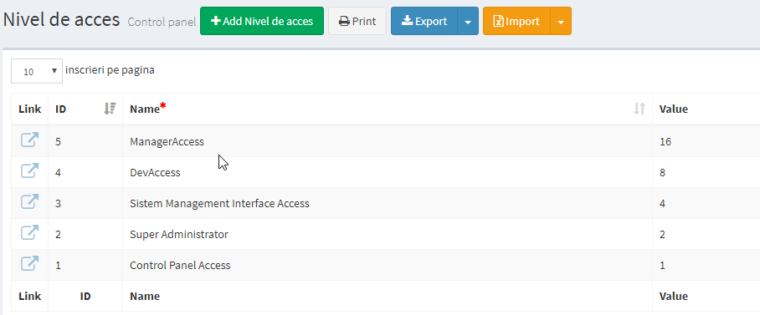

In the following table the permissions are given to existing users:

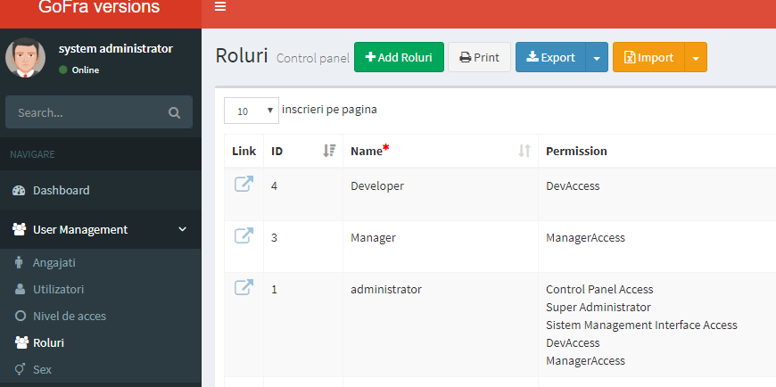

# 2. Adding a permission

1. Add to Enumeration in LIB\BusinessObjects\BasePermissionenum.cs

TestState = 8

Where:

* TestState – name of state
* 8 – degree of 2 (1,2,4,8,16,etc....)

1. Add to permission Static Class

public static readonly Permission TestState = new Permission(4, 8) { Name = "Test Administrator" };

Where:   
4 – Id from SMI  
8 – the same like in Enumeration

1. Add to LoadPermissions

If (Tools.Security.Permissions.HasPermissions(Permissions, TestAdmin.Value))

Perms.Add(TestAdmin.Id, TestAdmin);

In addition, add in bottom:

if (TestAdmin.Id == id)

return TestAdmin;

1. Add to SMI

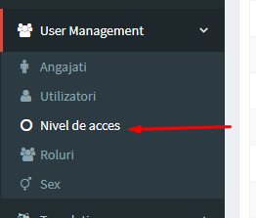



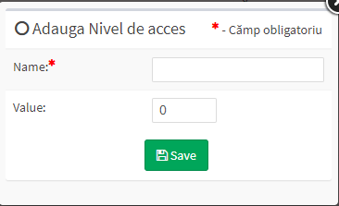

Name = TestAccess

Value = 8

(8 - the same like in Enumeration)